**Comprehensive Analysis of Random Forest Regressor and Critical Evaluation**

# Introduction

This report comprehensively analyzes the performance, limitations, and applicability of the Random Forest Regressor in real-world scenarios, demonstrating the importance of critical thinking and creative problem-solving abilities in tackling complex machine learning problems. By delving into the theoretical foundations of the Random Forest Regressor, we explain the principles of ensemble learning and the core mechanisms of the Random Forest algorithm, including the construction process of decision trees, the generation of forests, and how to form the final output by aggregating predictions from multiple decision trees.

The Random Forest Regressor was implemented using Python and the scikit-learn library, and through rigorous experimental design, explored the impact of different hyperparameters (such as tree depth, number of estimators, and feature selection methods) on model performance. Through systematic experiments, we analyze in detail how hyperparameter settings affect the predictive accuracy and generalization ability of the model.

Additionally, this study evaluates the performance of the Random Forest Regressor using regression evaluation metrics such as Mean Squared Error (MSE), R-squared, and Mean Absolute Error (MAE). Through comparative analysis with other regression models (such as linear regression, gradient boosting regressor), we critically assess the strengths and limitations of the Random Forest Regressor, particularly in terms of interpretability, computational complexity, and scalability.

We also conduct feature importance analysis to identify the most influential features in the Random Forest Regressor model and critically evaluate the interpretability of the model as well as the reliability of feature importance scores in guiding the decision-making process. Finally, the study proposes innovative solutions and strategies to address the limitations and challenges faced by the Random Forest Regressor, and explores potential future research directions in ensemble modeling techniques, emphasizing the role of critical thinking and creativity in advancing the field of ensemble learning.

# 1. Theoretical Understanding and Background

This section briefly outlines the basic concepts of ensemble learning and its role in machine learning.

## 1.1 Principles of ensemble learning

Ensemble learning is a machine learning paradigm that aims to improve learning performance by constructing and combining multiple learners (often referred to as base learners) to accomplish learning tasks more effectively than a single learner. The fundamental idea is to aggregate the predictions of multiple learners in some form (such as voting, averaging, or weighting) to obtain the final prediction. The key to ensemble learning lies in how these learners are generated and combined.

Ensemble learning can be broadly categorized into two main types: Bagging and Boosting.

#### 1.1.1 Bagging (Bootstrap Aggregating)

Bagging involves generating multiple diverse training subsets by repeatedly resampling the original dataset using bootstrap sampling. Then, multiple base learners are trained independently on these subsets, and their predictions are aggregated using simple methods such as majority voting or averaging. Random Forest is a typical example of a Bagging algorithm based on decision trees (Breiman, 1996).

#### 1.1.2 Boosting

Boosting is a method that can boost weak learners into strong learners. Unlike Bagging, where base learners are trained in parallel, Boosting algorithms train base learners sequentially. Each base learner adjusts the sample distribution based on the performance of the previous learner, focusing more on the samples misclassified by the previous learner, thereby gradually improving the model's performance. Typical Boosting algorithms include AdaBoost and Gradient Boosting(Freund & Schapire, 1997).

In summary, ensemble learning harnesses the power of multiple learners to enhance learning performance, with Bagging focusing on parallel training of diverse learners and Boosting emphasizing sequential training to gradually improve the model's capabilities.

## 1.2 The role of ensemble learning in machine learning

#### 1.2.1 Performance improvement

By combining multiple learners, ensemble learning often achieves higher prediction accuracy and generalization ability than a single learner.

#### 1.2.2 Reducing overfitting

Especially in cases where base learners are prone to overfitting, such as decision trees, ensemble learning can effectively reduce the risk of overfitting.

#### 1.3.3 Enhancing robustness

Different learners may perform better on different data subsets or different aspects of a problem. Ensemble learning can integrate these strengths, improving the model's adaptability and robustness to changes in data.

In conclusion, ensemble learning typically achieves better performance than a single model in complex machine learning tasks by harnessing the predictive capabilities of multiple learners.

## 1.3 Theoretical basis of random forest regressor

Random Forest is an ensemble learning algorithm primarily used for classification and regression tasks. It enhances the overall model performance by constructing multiple decision trees and aggregating their predictions.

The working principle of Random Forest can be divided into several key steps:

#### 1.3.1 Building Decision Trees

Random Sampling of Data: Each tree in the Random Forest is trained using a sample set obtained by bootstrap sampling from the original dataset, a process known as bootstrapping. This means that the same data may appear multiple times in one sample set, while some data may be omitted.

Random Selection of Features: At each split node of the decision tree, the algorithm does not consider all features to choose the best splitting feature. Instead, it randomly selects a subset of features and splits the node based on the best splitting feature within this subset. This randomness helps increase the diversity of the model.

Construction of Decision Trees: Using the aforementioned sample sets and feature subsets, each decision tree is independently constructed until reaching specific stopping criteria, such as maximum tree depth, minimum number of samples in nodes, or purity of samples in nodes.

#### 1.3.2 Generation of the Forest

Random Forest constructs a large number of decision trees through the above process, forming a "forest." The training process of each tree is independent of others, making it easy to parallelize the Random Forest algorithm.

#### 1.3.3 Aggregation of Prediction Results

For Classification Tasks: In classification problems, Random Forest determines the final class output through a "voting" mechanism. That is, each tree provides a prediction result, and the final classification result is determined by the majority of trees in the forest (i.e., the mode). For example, if you have 500 trees, where 300 predict class A and 200 predict class B, the output of the Random Forest will be class A.

For Regression Tasks: In regression problems, the prediction result of Random Forest is the average of all decision tree prediction results. This means each tree provides a numerical prediction, and the final prediction of the Random Forest is the arithmetic average of all tree prediction values.

The advantages of the Random Forest algorithm lie in its high flexibility and adaptability, its ability to handle high-dimensional data without requiring much preprocessing, such as normalization. It also exhibits good resistance to overfitting, especially with a large number of decision trees. Additionally, Random Forest can provide estimates of feature importance, which is very useful for interpreting model predictions.

# 2. Implementation and Experimentation

This study utilized Python and scikit-learn to implement the Random Forest Regressor.

## 2.1 Code implementation process

The following diagram illustrates the workflow of the code implementation process, starting from "Data Reading" and continuing through various steps until "Comparison between Random Forest Regression and Gradient Boosting Regression." It clearly indicates the logical sequence of the entire experimental design and analysis.

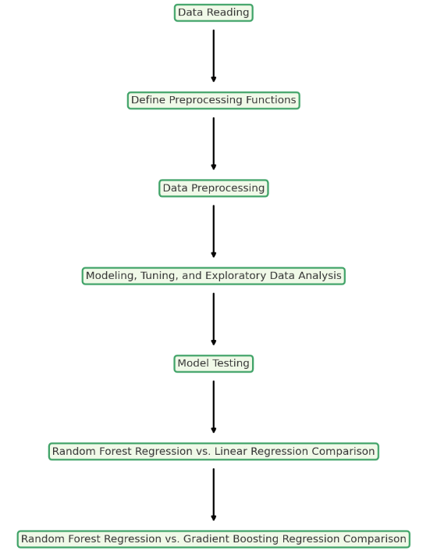

## 2.2 Key steps in code implementation

Key steps of implementing Random Forest Regressor and conducting comprehensive analysis in this study are as follows. These key steps cover the entire process from data preprocessing to model training, evaluation, tuning, and result interpretation, providing a comprehensive guide for building a robust and well-performing Random Forest Regression model.

#### 2.2.1 Data Preparation and Preprocessing

-Dataset:

The Titanic dataset contains personal information of passengers and their survival status from the 1912 Titanic shipwreck.

Key fields typically include:

- PassengerId: Passenger number.

- Survived: Survival status (0 = Not survived, 1 = Survived).

- Pclass: Ticket class, representing socio-economic status (1 = First class, 2 = Second class, 3 = Third class).

- Name: Passenger's name.

- Sex: Gender.

- Age: Age.

- SibSp: Number of siblings/spouses aboard the Titanic.

- Parch: Number of parents/children aboard the Titanic.

- Ticket: Ticket number.

- Fare: Fare.

- Cabin: Cabin number.

- Embarked: Port of embarkation (C = Cherbourg, Q = Queenstown, S = Southampton).

- Data Reading: Use pandas to read the dataset.

- Data Cleaning:

- Impute missing values.

- Convert categorical variables to numerical (e.g., gender field).

- Remove unnecessary fields such as passenger ID, name, and ticket number.

- Feature Engineering: Extract and transform features, such as extracting the first letter from the Cabin field and performing One-Hot Encoding.

#### 2.2.2 Data Splitting

- Randomize Dataset: Randomize the dataset to ensure model generalization.

- Train-Test Split: Split the dataset into training and validation (or testing) sets.

#### 2.2.3 Model Building

- Initialize Random Forest Regressor: Set parameters of the Random Forest Regressor, such as the number of trees (n_estimators), maximum depth (max_depth), etc.

- Model Training: Train the model using the training dataset.

#### 2.2.4 Model Evaluation

- Performance Evaluation: Evaluate model performance on the training and validation sets by calculating R² value and Root Mean Square Error (RMSE).

#### 2.2.5 Hyperparameter Tuning

- Random Search: Use RandomizedSearchCV to perform random search on the parameters of the Random Forest Regressor to find the optimal parameter combination.

#### 2.2.6 Feature Importance Analysis

- Analysis and Visualization: Analyze the importance of each feature in the model and visualize it through charts to identify the features that have the most significant impact on model prediction performance.

#### 2.2.7 Model Comparison

- Compare with Other Models: Compare the performance of the Random Forest Regressor with other models (such as linear regression, gradient boosting regressor) to assess its relative performance.

#### 2.2.8 Result Visualization

- Performance Comparison Plot: Plot performance comparison graphs of different models, including R² value and RMSE.

- Feature Importance Plot: Visualize the importance of each feature in the model.

- Calibration Curve: Plot calibration curves to evaluate the accuracy of the model's probability predictions.

## 2.3 Experimental design for hyperparameters

The following outlines the criteria and strategies for selecting and adjusting hyperparameters such as tree depth, number of estimators, and feature selection methods:

In machine learning models, hyperparameters are parameters set before the learning process begins, and their values cannot be learned from the data. For ensemble learning algorithms like Random Forest, the main hyperparameters include tree depth, the number of estimators (i.e., the number of trees), and feature selection methods. Below are the criteria and strategies for selecting and adjusting these hyperparameters:

1. Tree Depth (max_depth): The tree depth refers to the maximum number of levels in a decision tree. Trees with small depths may fail to fully represent the complexity of the data, leading to underfitting, while trees with large depths may be overly complex, resulting in overfitting. Selecting and adjusting tree depth typically requires determining the optimal value through cross-validation. Different depth values, such as 5, 10, 15, etc., can be tried, and the model's performance on the validation set can be observed.

2. Number of Estimators (n_estimators): The number of estimators refers to the number of trees in the Random Forest. Generally, the more trees, the higher the stability and accuracy of the model, but the computational cost also increases. Start with a small number of trees (e.g., 10, 50, 100), and gradually increase the number of trees based on the performance on the validation set until the model's performance no longer significantly improves.

3. Feature Selection Method (feature_selection): Feature selection involves selecting the subset of features from the original features that are most helpful for predicting the target variable. Common feature selection methods include maximum information gain, Gini impurity, ranking by correlation coefficient, etc. Feature selection can not only reduce training time but also improve the model's generalization ability. It usually requires combining domain knowledge and statistical analysis of features to select features or using the model's own feature importance evaluation for assistance.

4. Other Hyperparameters: In addition to the above-mentioned hyperparameters, there are others such as minimum samples for split (min_samples_split), minimum samples for leaf node (min_samples_leaf), feature sampling methods (such as max_features), etc., which also need to be adjusted through experiments.

In this experiment, the criteria and strategies for selecting and adjusting hyperparameters such as tree depth, the number of estimators, and feature selection methods can be summarized as follows:

1. Initial Parameter Range Selection: In each round of parameter tuning, first choose an initial parameter range covering possible values. In this example, the initial parameter range includes the number of trees (n_estimators), the maximum depth of each tree (max_depth), and the number of features to consider when looking for the best split (max_features).

2. Randomized Search Tuning: Use randomized search (RandomizedSearchCV) to search the parameter space. Through randomized search, parameters are randomly selected within the specified parameter space for evaluation, effectively finding the optimal parameter combination.

3. Cross-Validation: Employ cross-validation (cv=5) to evaluate the performance of each parameter combination. This allows for a better estimation of the model's generalization ability on unseen data.

4. Iterative Tuning: Conduct multiple rounds of hyperparameter tuning, adjusting parameters based on the results of the previous round. In each round, refine the parameter search space based on the performance of the previous round's search results.

5. Performance Evaluation: After each round of tuning, evaluate the performance of the best model on the training and validation sets, including metrics such as R-squared and RMSE.

6. Model Comparison: After tuning, compare the best models obtained from different rounds to find the model with the best performance.

## 2.4 Analysis of the impact of hyperparameters on model performance

Through systematic experimental design, the following discusses the impact of different hyperparameter configurations on model performance and provides experimental results and analysis. This study aims to delve into the influence of different configurations on model performance through three rounds of hyperparameter tuning experiments on the Random Forest model. Here is a detailed analysis of the experimental results:

- Results of the 1st Round of Tuning:

- Best Parameter Combination: `{'n_estimators': 200, 'max_features': 'log2', 'max_depth': 5}`

- Performance on Training Set: R-squared value of 0.31, RMSE of 0.40

- Performance on Validation Set: R-squared value of 0.20, RMSE of 0.44

- Results of the 2nd Round of Tuning:

- Best Parameter Combination: `{'n_estimators': 100, 'max_features': None, 'max_depth': 5}`

- Performance on Training Set: R-squared value of 0.26, RMSE of 0.42

- Performance on Validation Set: R-squared value of 0.19, RMSE of 0.44

- Results of the 3rd Round of Tuning:

- Best Parameter Combination: `{'n_estimators': 50, 'max_features': None, 'max_depth': 10}`

- Performance on Training Set: R-squared value of 0.62, RMSE of 0.30

- Performance on Validation Set: R-squared value of 0.16, RMSE of 0.45

- n_estimators (Number of Trees):

- Increasing the number of trees to 200 in the first round showed superior performance on the training set (higher R-squared value and lower RMSE) compared to the second (100 trees) and third rounds (50 trees).

- However, on the validation set, increasing the number of trees did not significantly improve performance and may have led to slight overfitting, as seen in the slightly lower validation set R-squared in the third round compared to the second.

- max_depth (Maximum Tree Depth):

- In the third round, increasing the maximum tree depth to 10 significantly improved the model's performance on the training set compared to the first round's depth of 5, reflected in a higher R-squared value.

- However, this increase in depth did not have a positive impact on validation set performance and may have caused overfitting, as indicated by the slight decrease in validation set R-squared and RMSE.

- max_features (Feature Selection Method):

- In the first and second rounds, although different feature selection methods were employed ('log2' and None), there was no significant difference in performance.

- In the third round, despite using None again, possibly due to adjustments in other hyperparameters, the model performed better on the training set compared to the second round, while performance on the validation set slightly declined.

The choice of hyperparameters significantly affects model performance, but optimization requires a comprehensive evaluation based on performance on both the training and validation sets. Increasing the number of trees and maximum depth helps improve training set performance but may lead to overfitting. The feature selection method has a relatively minor direct impact on model performance, but its potential effect should still be considered when adjusting other hyperparameters. Therefore, selecting appropriate hyperparameter configurations is crucial for optimizing model performance and requires balancing performance on both the training and validation sets.

# 3. Evaluation and Interpretation

## 3.1 Performance evaluation of random forest regressor

This study used two regression evaluation indicators, RMSE and R-squared, to evaluate model performance.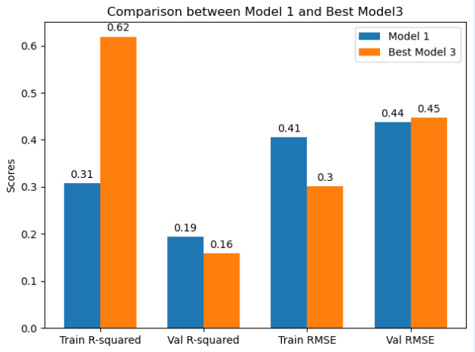

The picture above is a performance comparison chart between Model1 and Best Model3. Best Model 3 and Model 1 are two models with different configurations built through the random forest regression algorithm.

Train R-squared:

Model 1 has an R-squared value of 0.31 on the training set, indicating that it can explain 31% of the variability in the data. Best Model 3 significantly outperforms Model 1 on the training set with an R-squared value of 0.62, explaining 62% of the variability in the data. This suggests that Best Model 3 fits the training data better.

Val R-squared:

On the validation set, Model 1 achieves an R-squared value of 0.2, while Best Model 3 has an R-squared value of 0.16. This indicates that Model 1 performs slightly better than Best Model 3 on unseen data, although both models' performance is not very high.

Train RMSE:

Model 1 has a training RMSE of 0.4, whereas Best Model 3 has a lower training RMSE of 0.3. A lower RMSE implies smaller prediction errors, indicating higher predictive accuracy of Best Model 3 on the training set.

Val RMSE:

For the validation set, Model 1 has an RMSE of 0.44, while Best Model 3 has an RMSE of 0.45, indicating nearly identical prediction errors on the validation set.

Overall, Best Model 3 performs better on the training set, exhibiting higher R-squared values and lower RMSE. However, on the validation set, Model 1 slightly outperforms Best Model 3 in explaining variability in the data, suggesting potential overfitting of Best Model 3 on the training set as its performance slightly drops on unseen data.

## 3.2 Model performance explaination

Training Set Performance:

The R-squared value of 0.62 for Best Model 3 on the training set is significantly higher compared to 0.31 for Model 1. This indicates that Best Model 3 can explain more variability in the data, suggesting a better fit to the training data.

The training RMSE of 0.3 for Best Model 3 is lower than 0.4 for Model 1, indicating smaller prediction errors and higher accuracy on the training set for Best Model 3.

Validation Set Performance:

On the validation set, Model 1 slightly outperforms Best Model 3 with an R-squared value of 0.2 compared to 0.16 for Best Model 3. Although both models exhibit relatively low performance on unseen data, Model 1 has a slight advantage in explaining the variability in the data.

The RMSE values on the validation set are nearly identical (0.44 for Model 1 and 0.45 for Best Model 3), indicating similar prediction errors for both models on the validation set.

## 3.3 Factors affecting model performance

Overfitting and Underfitting:

The superior performance of Best Model 3 on the training set compared to Model 1, coupled with a decrease in performance on the validation set, suggests that Best Model 3 may be experiencing overfitting. Overfitting occurs when a model becomes overly complex, learning noise in the training data rather than just the underlying signal, leading to poor performance on new, unseen data.

Model Complexity: Best Model 3 may have a higher model complexity, such as more trees or deeper trees, which helps achieve better performance on the training data but also increases the risk of overfitting.

Data Features and Quality: The performance of the model is also influenced by the features used and the quality of the data. If the features used by the model fail to capture the variability of the target variable adequately, or if there is a significant amount of noise in the data, the predictive performance of the model may be limited.

Hyperparameter Settings: The performance of the random forest regressor is significantly influenced by its hyperparameters, including the number of trees, maximum tree depth, minimum samples per leaf, etc. Inappropriate hyperparameter settings can lead to either overfitting or underfitting of the model.

## 3.4 Strategies to improve model performance

Cross-validation: Use cross-validation to optimize the selection of hyperparameters to find the model configuration with the best generalization performance.

Regularization: Apply regularization techniques (such as pruning) to limit the complexity of the tree and reduce the risk of overfitting.

Feature selection and engineering: Improve the input to the model through feature selection and feature engineering, removing irrelevant features or creating more informative features.

Diversity of ensemble learning methods: Try different ensemble learning algorithms, such as Gradient Boosting or XGBoost, and adjust their hyperparameters to improve the model's performance on unseen data.

## 3.5 Predictive performance of random forest regressor

This study randomly selected 200 samples from the training set as test data to evaluate the prediction performance of the model.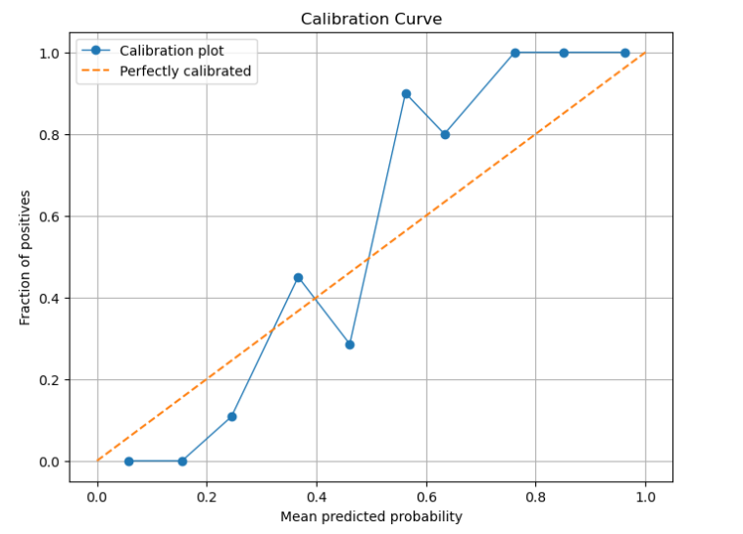

The diagram above is a calibration curve used to assess the accuracy of predicted probabilities in RF model. The horizontal axis represents the "Mean predicted probability," ranging from 0 to 1, while the vertical axis represents the "Fraction of positives," also ranging from 0 to 1.

There are two lines on the chart:

A solid blue line (with blue circles), labeled as "Calibration plot," which depicts the relationship between the model's predicted probabilities and the actual fraction of positives. If the model is perfectly accurate, this line should closely follow the dashed line.

An orange dashed line, labeled as "Perfectly calibrated," represents ideal predictions where predicted probabilities perfectly match the actual fraction of positives.

From this chart, we can observe that the blue solid line deviates from the ideal orange dashed line at certain predicted probabilities. This indicates that the model's prediction accuracy is not perfect at these specific predicted probability values. For example, around the position of approximately 0.3 on the horizontal axis, the predicted fraction of positives is lower than the ideal scenario, whereas around the position of approximately 0.6, the predicted fraction of positives suddenly exceeds the ideal scenario, followed by a rapid decrease. These deviations suggest that the model's predictions in these probability intervals require calibration.

Overall, the difference between the ideal model prediction line (orange dashed line) and the actual model prediction line (blue solid line) reflects the inaccuracy of the model's predictions. A well-calibrated model's prediction line will be closer to the ideal prediction line.

# 4. Comparative Analysis Among different Regression Models

## 4.1 Comparing Random Forest Regressor to Linear Regression

This study initialized a linear regression model instance from the scikit-learn library, trained it with the training dataset `x_train` and the target variable `y_train`, and then made predictions on the test dataset. A comparison was then made in terms of performance with the random forest regression model.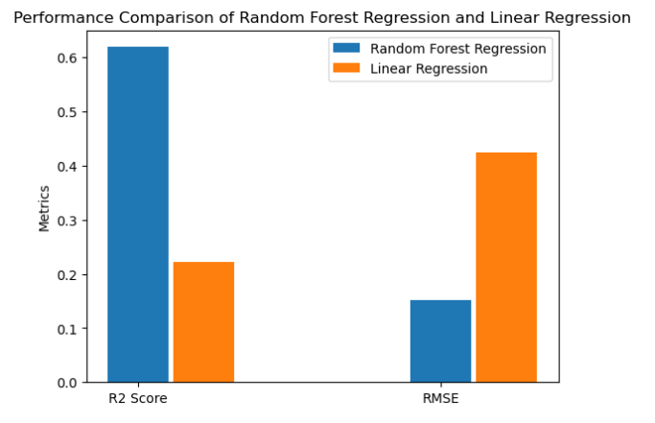

This bar chart above illustrates the comparison between Random Forest Regression and Linear Regression in terms of performance. There are two sets of bars in the chart, each representing two different metrics for each model: R² score and Root Mean Squared Error (RMSE).

The blue bars represent the Random Forest Regression model.

The orange bars represent the Linear Regression model.

From the chart, it is evident that Random Forest Regression significantly outperforms Linear Regression in terms of the R² score metric. This indicates that the Random Forest Regression model fits the training data better. However, in terms of the RMSE metric, the value for Linear Regression is notably higher than that of Random Forest Regression, indicating that the Linear Regression model has larger prediction errors on the test set.

## 4.2 Comparing Random Forest Regressor to Gradient Boosting Regressor

This study also compared the performance of random forest regression and gradient boosting regression on the same test dataset. The evaluation was based on two key metrics, namely R² value and RMSE, to assess the accuracy of the models and their prediction errors. This comparison aimed to determine which model is more suitable for the current dataset and problem.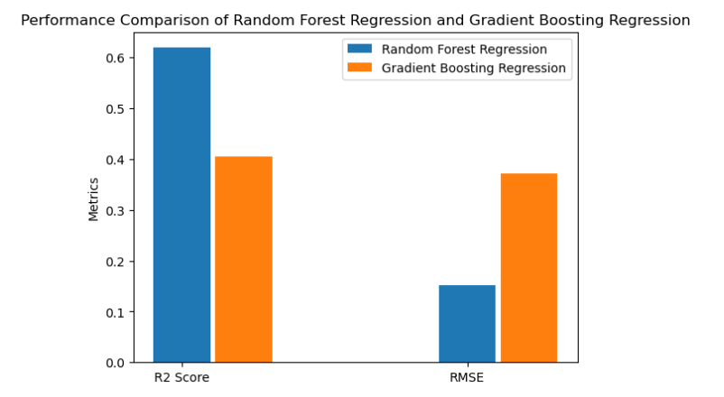

The Random Forest Regressor has a higher R² value than the Gradient Boosting Regressor, indicating that Random Forest performs better in explaining the variability of the data. Random Forest Regressor leads in R² score, indicating a higher degree of fit between predicted values and actual values. Additionally, the Random Forest Regressor has a lower RMSE score, indicating smaller prediction errors.

In practical applications, the choice of model depends on the specific requirements of the problem. If there is a high demand for interpretability of the model, one may prefer the model with a higher R² score. Conversely, if there is a higher requirement for prediction accuracy, one may choose the model with a lower RMSE score.

## 4.3 Critical evaluation of model strengths and weaknesses

#### 4.3.1 Interpretability

- Linear Regression (LR): Exhibits high interpretability as the model's output can be directly explained by the weights of input features, making it easy to understand and interpret the model's decision process.

- Random Forest (RF): Relative to linear regression, RF has lower interpretability. While individual decision trees are easy to understand, the complexity increases with the ensemble of multiple decision trees in a random forest, making it more challenging to interpret the overall model's decision process and results.

- Gradient Boosting Regression (GBR): Falls between LR and RF in terms of interpretability. Although it is also based on decision trees, the interpretability is not as straightforward as a single decision tree due to the sequential construction of trees and the focus on correcting errors. However, sometimes insights can be gained by analyzing the contributions of individual trees.

#### 4.3.2 Computational Complexity

- Linear Regression (LR): Typically has lower computational complexity, especially when the number of features is not particularly large. Training and prediction are fast, making it suitable for large-scale data processing.

- Random Forest (RF): Has higher computational complexity due to the need to build multiple decision trees. Although parallel computation is possible, training and prediction times increase as the number of trees or the size of the dataset grows.

- Gradient Boosting Regression (GBR): Usually has higher computational complexity than random forest due to the sequential construction of trees, making parallelization of the training process difficult, especially with large amounts of data and trees.

#### 4.3.3 Scalability

- Linear Regression (LR): Demonstrates good scalability, especially for large datasets. Linear models can be efficiently trained using various methods such as stochastic gradient descent.

- Random Forest (RF): Has some scalability, particularly with parallel tree construction during training. However, the model's size (i.e., storage requirements for all trees) may become a limiting factor with very large datasets.

- Gradient Boosting Regression (GBR): Relatively less scalable due to the sequential construction of trees. Training a GBR model on very large datasets may become very slow.

#### 4.3.4 Summary

- Linear regression excels in simplicity and interpretability but may struggle with complex nonlinear relationships.

- Random forest has advantages in handling nonlinear problems and feature interactions but sacrifices some interpretability and computational efficiency.

- Gradient boosting regression typically offers the highest prediction accuracy, especially in competitions and complex problems, but at the expense of computational efficiency and interpretability.

# 5. Feature Importance and Interpretability

## 5.1 Feature importance analysis

The following will identify and explain the most influential features in a Random Forest Regressor model.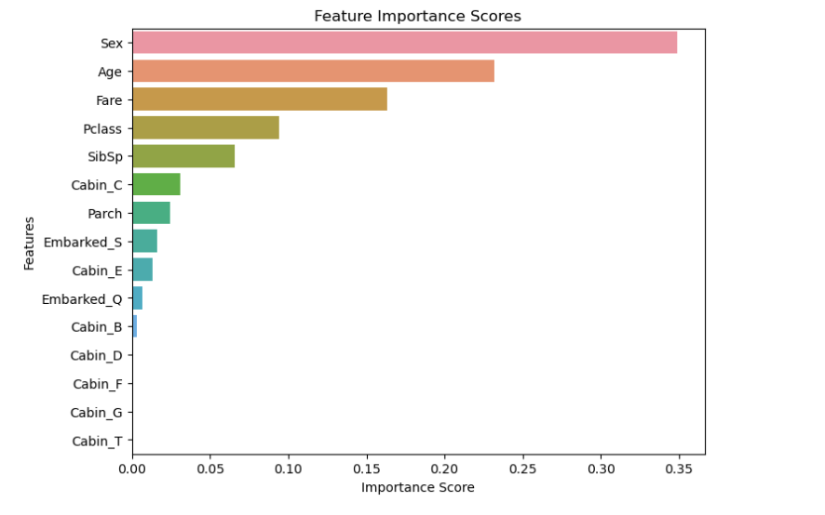

From the graph above, it can be observed that for Model 1:

Gender (Sex) is the most important feature, with the highest importance score, far exceeding other features.

Age and Fare are also relatively important features, but their importance scores are significantly lower than Gender.

Passenger Class (Pclass) and Siblings/Spouses (SibSp) have moderate importance.

Features related to Cabin, such as Cabin_C, Cabin_E, and Embarked, have lower importance.

The importance score of Cabin_T is the lowest among all features.

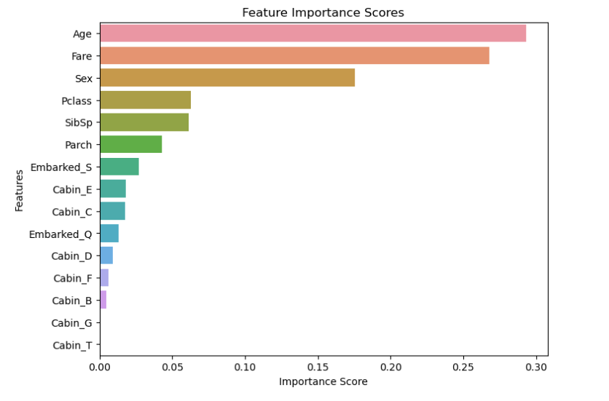

From the graph above, it can be observed that for Best Model 3:

Age: This is the most important feature, with its importance score far exceeding other features.

Fare: Following Age closely, it is the second most important feature.

Sex: While relatively important, the importance score of the Sex feature is lower than Age and Fare.

Passenger Class (Pclass), Siblings/Spouses (SibSp), and Parents/Children (Parch): These features have moderate importance scores.

Embarked: Representing different embarkation ports, the importance score of Embarked is relatively low.

Cabin: Representing different cabin positions or types, the importance of Cabin features ranks lower among other features, with Cabin_T having the lowest score.

If a feature has a low importance score, it means that it contributes little to the improvement of the model's performance. Sometimes, removing these features can simplify the model, reduce the risk of overfitting, and improve the model's training and prediction speed. In both models, Parch is considered to be a feature with less impact. Therefore, we will use the data after removing Parch for model training again.

The purpose of removing less important features is to simplify the model, reduce unnecessary computational complexity, and attempt to improve the model's generalization ability.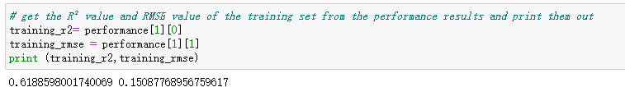

However, this approach only resulted in minor changes in model performance in this study. In some cases, removing unimportant features may slightly improve the accuracy of the model, or at least maintain performance, as it helps reduce the model's sensitivity to noise. This method of optimizing the model based on feature importance assessment is a common practice in machine learning, contributing to improving the efficiency and effectiveness of models.

## 5.2 Model interpretability and reliability of feature importance scores

The following critically evaluates the interpretability of the model and the guiding role of feature importance scores in the decision-making process. The reliability of model interpretability and feature importance scores is a crucial issue in the field of machine learning, especially in applications where important decisions are made based on the model.

#### 5.2.1 Model interpretability

Linear models, such as linear regression, are generally considered to have high interpretability because the model's output can be directly interpreted through its coefficients. Each coefficient represents the magnitude and direction of its corresponding feature's influence on the predicted variable. This direct relationship makes linear models very intuitive in terms of interpretability.

Tree-based models, such as random forests and gradient boosting regression, while each tree's decision process is relatively easy to understand, the overall interpretability of the model decreases when the model contains a large number of trees. Nevertheless, the feature importance scores of these models still provide valuable insights into which features have a significant impact on the prediction results.

#### 5.2.2 Reliability of feature importance scores

Feature importance scores provide information about which features contribute the most to the model's predictive performance. In random forests, feature importance is typically based on the contribution of features to the improvement of model error, such as by calculating the average decrease in impurity due to a feature split.

However, the reliability of feature importance scores may be influenced by several factors, including data noise, feature correlations, and model hyperparameter configurations. For example, highly correlated features may cause the importance scores to be distributed among these features, thereby reducing the importance score of individual features.

In gradient boosting regression, feature importance scores similarly indicate the contribution of features to the prediction target. However, because the model constructs trees sequentially to correct errors from the previous tree, this may result in the estimation of feature importance being more focused on those features that are most helpful in reducing prediction errors.

#### 5.2.3 Methods to enhance the reliability of feature importance scores

Cross-validation: By repeating model training and feature importance evaluation on different subsets of data, more stable estimates of feature importance can be obtained.

Noise reduction: Before evaluating feature importance, reducing noise in the data through appropriate data cleaning and preprocessing steps can improve the accuracy of feature importance scores.

Consideration of feature interactions: Some advanced feature importance assessment methods, such as permutation importance, evaluate the impact of features on model performance by randomly permuting feature values, aiding in capturing interactions between features.

# 6. Innovative Solutions and Future Directions

## 6.1 Limitations of Random Forest Regressor Identification

#### 6.1.1 Calculation cost

Random forests require building multiple trees, which can result in high computational costs, especially for large datasets or when a large number of trees is needed to improve model performance.

#### 6.1.2 Model complexity and interpretability

While individual trees are interpretable, random forests composed of multiple trees have lower overall interpretability, especially when there are many trees.

#### 6.1.3 Overfitting to some noise

Although random forests are robust against overfitting, they may still overfit to some noise in datasets with significant noise.

## 6.2 Innovative Solutions & Potential future research directions

Optimizing algorithms and leveraging parallel computing frameworks are essential for enhancing the efficiency of machine learning models like Random Forests, especially to reduce training times and computational costs in the face of large datasets. Approximate methods for tree construction, such as quantile-based splitting or histogram-based approaches, can significantly narrow down the search space for splitting points, thus streamlining the model training process. Furthermore, parallel computing, by distributing the tree-building process across multiple nodes, can exploit the inherently parallelizable structure of Random Forests, drastically reducing computational overhead while ensuring workload balance and minimizing communication bottlenecks (Liaw & Wiener, 2002).

Enhancing the interpretability of Random Forests is another critical area, where the development of tools for feature importance visualization and single tree analysis can provide insights into the model's decision-making process. Model distillation techniques, which aim to simplify complex models without sacrificing performance, offer a pathway to distill the knowledge from Random Forests into more interpretable models, thus bridging the gap between performance and transparency (Buciluǎ, Caruana, & Niculescu-Mizil, 2006).

Preventing overfitting involves advanced regularization techniques like limiting tree depth and adjusting the minimum number of samples per leaf node. Dropout techniques, adapted from deep learning, introduce randomness during the training phase by omitting subsets of trees, thereby enhancing the model's robustness to data noise. Cross-validation and out-of-bag (OOB) error estimates are indispensable for tuning the model's hyperparameters to optimize its generalization capabilities (Breiman, 2001).

Addressing the challenges posed by high-dimensional data requires effective feature selection and dimensionality reduction techniques to retain the most informative features while discarding redundant ones. Hybrid models that combine Random Forests with other algorithms, such as deep learning models for feature extraction, present a promising approach to handling complex data structures and enhancing model performance (Caruana et al., 2004).

These multifaceted strategies, from algorithmic optimization and interpretability enhancement to regularization and handling high-dimensional data, underscore the dynamic nature of ensemble learning research, pointing towards a future where models are not only powerful and efficient but also transparent and adaptable to various data challenges.

# References

Breiman, L. (1996). Bagging predictors. Machine Learning, 24(2), 123-140.

Breiman, L. (2001). Random Forests. Machine Learning, 45(1), 5-32.

Buciluǎ, C., Caruana, R., & Niculescu-Mizil, A. (2006). Model Compression. Proceedings of the 12th ACM SIGKDD International Conference on Knowledge Discovery and Data Mining, 535-541.

Caruana, R., Niculescu-Mizil, A., Crew, G., & Ksikes, A. (2004). Ensemble selection from libraries of models. Proceedings of the twenty-first international conference on Machine learning, 18.

Freund, Y., & Schapire, R. E. (1997). A decision-theoretic generalization of on-line learning and an application to boosting. Journal of Computer and System Sciences, 55(1), 119-139.

Liaw, A., & Wiener, M. (2002). Classification and Regression by randomForest. R News, 2(3), 18-22.